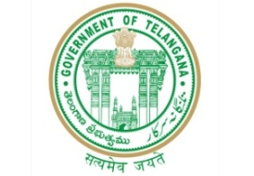 **GOVERNMENT OF TELANGANA**

**TELANGANA TRIBAL WELFARE RESIDENTIAL DEGREE COLLEGE (GIRLS), MAHABUBABAD: MAHABUBABAD-DIST**

**https://www.ttwrdcs.ac.in/Mahabubabad**

**E-Mail Id:ttwrdcgirls.mahabubabad@gmail.com Cell No: 7901097695**

**Statistical Quiz "P.C Mahalanobis"**

**Date : 22/09/23**

**Venue : Seminar Hall**

**Participants : 15**

**Beneficiaries : 31**

A quiz was organized by the statistics department for the students of second and final year. Quiz was successful in many aspects. There were two rounds in the quiz i.e. Q&A and rapid fire.

3 teams participated with 5 member’s each. Team B was the winner and the participants were Saipriya , Shilpa, Manasa, preethi , Jyothi. All the Students of the department attended the quiz.

